[font: 12 pt, 2 blank lines]

**Paper title**

**Name and surname**

Author's institution, title and e-mail address

**Name and surname**

Author's institution, title and e-mail address

**Name and surname**

Author's institution, title and e-mail address

[2 blank lines, font 11 pt]

**Abstract** [font: 11 pt, bold]: Abstract in Croatian and English, along with key words, must fit on the first page of the article. [font:11 pt, alignment justified]

Papers no longer than eight pages can be published in Croatian and English.

**Key words** [font: 11 pt, bold]: key words in English [font: 11 pt, alignment justified]

[2 blank lines, font 11 pt]

**Naslov rada**

**Sažetak** [font: 11 pt, bold]: Sažetak na hrvatskom i engleskom jeziku, zajedno s ključnim riječima mora se smjestiti u okviru prve stranice članka. [font:11 pt, alignment justified]

[1 blank line, font 11 pt]

**Ključne riječi** [font: 11 pt, bold]: ključne riječi na hrvatskom [font: 11 pt, alignment justified]

[font: 12 pt, 2 blank lines]

**1. TEXT FORMATTING** [font: 12 pt, bold]

[1 blank line, font 12 pt]

Text is written in Arial font. The main heading of the chapter is written in font size 12 pt, bold. Subheadings are written in font size 12 pt, bold. The first paragraph starts with no indent, and all other paragraphs in the same chapter are indented by 0.8 cm. Chapter heading or subheading number is followed by a tab character. Body text is aligned justified. [font: 11 pt, first paragraph with no indent]

Numerical or discrete methods, most commonly used for the design of raft foundations, are the finite difference method (FDM) and finite element method (FEM). These two methods will be examined in the following chapter. Other mostly used methods are the boundary element method, the surface element method and the finite grid method (FGM).

[1 blank line, font 11pt]

**1.1 Chapter subheading**

[1 blank line, font 12 pt]

Figure 1 shows a slab (the elastic modulus of concrete E=30 GPa and Poisson's ratio ν=0.2) and its dimensions, while the soil is represented by the coefficient of soil reaction of 4 MN/m3. The example considers only bending moments in the four axes, although the methods also give large responses, contact pressure forces and settlements. Weight of the slab is not considered, and column loads are defined as concentrated point loads. The finite difference method is applied using the software (Lopes, 2000), whose view is shown in Figure 2 and Table 1.

[1 blank line, font 11pt]

1

[1 blank line, font 11pt]

Figure 1. Figures and diagrams are aligned to the centre of the page

[1 blank line, font 11pt]

Modeling of soil response according to Winkler's hypothesis was carried out using the possibility of calculation of the coefficient of soil reaction from the provided program. We examined the case of a thin plate with springs at node places. The results are shown in Table 1 and Figure 2. The range of thickness/column values is approximate to 1/8, and

inclusion of deformations in the calculation did not significantly change values of bending moments.

**2. TABLES**

[1 blank line, font 12 pt]

Tables are aligned to the centre of the page.

[1 blank line, font 11pt]

Table 1. Tables are aligned to the centre of the page

[1 blank line, font 11pt]

|  |  |  |  |  |  |
| --- | --- | --- | --- | --- | --- |
| Axis | Moment  (kNm/m) | ACI | FDM | FEM  (Lopes) | Tower |
| 1 | M1 | 268 | 581 | 735 | 698 |
| M2 | -308 | -116 | -118 | -144 |
| M3 | 1034 | 1704 | 2013 | 1903 |

[2 blank lines, font 11pt]

**3. FORMULAS**

[1 blank line, font 12 pt]

Formulas are indented by one tab (0.8 cm) and are numbered in the order in which they appear in the text.

[1 blank line, font 11pt]

 (1)

[1 blank line, font 11pt]

Formulas are written according to the following template:

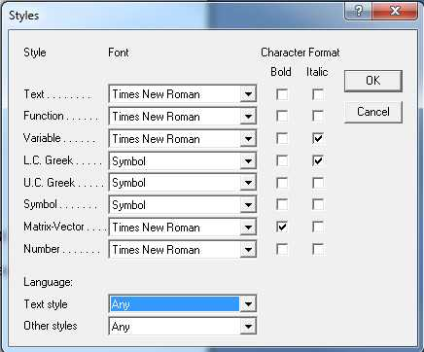

[1 blank line, font 11pt]

Figure 1. This is how to set the Style for Math text in Equation Editor [font: 11 pt, bold]

[2 blank lines, font 11pt]

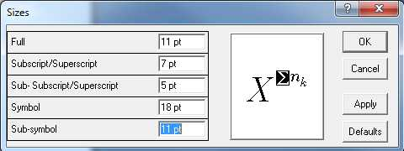

[1 blank line, font 11pt]

**REFERENCES**

1. Author's surname and initials of name: *Full title of cited article*, Journal name, year of publication, issue number, pp. from-to

2. Author's surname and initials of name: *Full title of the book*, Publisher name, place of publication, year of publication